**Learning Outcomes**

1. Understanding android UI and controls
2. Working with xml layout files

**Understanding Folder Structure in AndroidProject**

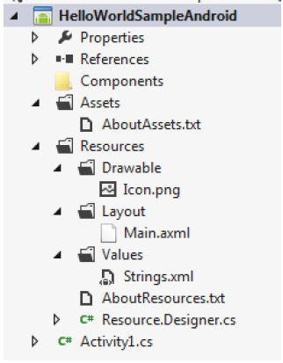

Assets folder is the location where the assets (image, xml, any file) are kept. These files would be copied along with the package file (APK) and copied to the device. Drawable folder is the location where the images used for background, custom control, etc… and the xml layout for custom control. Layout folder is the location for storing the layouts. Typically an AXML file could be designed in the designer, which has an XML view. But along with these AXML files, XML layouts are also kept here. Later we would see how we load a layout dynamically (from XML).

Values folder should contain Strings.xml and Styles.xml.

**Creating a Simple Calculator**

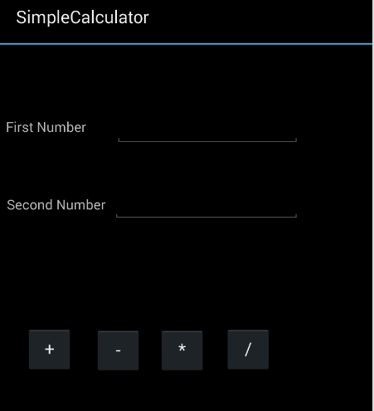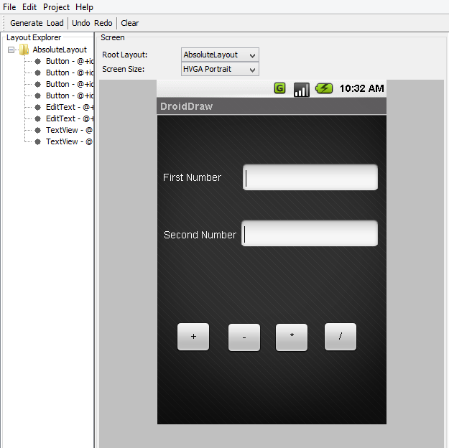

Create a layout as with two textboxes, labels and four buttons as shown above using Droiddraw.

<?xml version="1.0" encoding="utf-8"?>  
<AbsoluteLayout xmlns:android="http://schemas.android.com/apk/res/android"  
    android:id="@+id/widget0"  
    android:layout_width="fill_parent"  
    android:layout_height="fill_parent">  
    <Button  
        android:id="@+id/btnplus"  
        android:layout_width="50dp"  
        android:layout_height="wrap_content"  
        android:text="+"  
        android:layout_x="26dp"  
        android:layout_y="290dp" />  
    <Button  
        android:id="@+id/btnminus"  
        android:layout_width="50dp"  
        android:layout_height="wrap_content"  
        android:text="-"  
        android:layout_x="97dp"  
        android:layout_y="291dp" />  
    <Button  
        android:id="@+id/btnmul"  
        android:layout_width="50dp"  
        android:layout_height="wrap_content"  
        android:text="*"  
        android:layout_x="163dp"  
        android:layout_y="291dp" />  
    <Button  
        android:id="@+id/btnDivide"  
        android:layout_width="50dp"  
        android:layout_height="wrap_content"  
        android:text="/"  
        android:layout_x="231dp"  
        android:layout_y="290dp" />  
    <EditText  
        android:id="@+id/txtNum1"  
        android:layout_width="192dp"  
        android:layout_height="wrap_content"  
        android:textSize="18sp"  
        android:numeric="decimal"  
        android:layout_x="118dp"  
        android:layout_y="68dp" />  
    <EditText  
        android:id="@+id/txtNum2"  
        android:layout_width="194dp"  
        android:layout_height="wrap_content"  
        android:textSize="18sp"  
        android:layout_x="116dp"  
        android:layout_y="146dp" />  
    <TextView  
        android:id="@+id/widget44"  
        android:layout_width="wrap_content"  
        android:layout_height="wrap_content"  
        android:text="First Number"  
        android:layout_x="6dp"  
        android:layout_y="77dp" />  
    <TextView  
        android:id="@+id/widget45"  
        android:layout_width="wrap_content"  
        android:layout_height="wrap_content"  
        android:text="Second Number"  
        android:layout_x="7dp"  
        android:layout_y="157dp" />  
</AbsoluteLayout>

Before writing the code build your project so that the resource file is set up.

Declare the controls

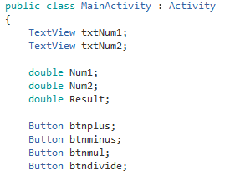

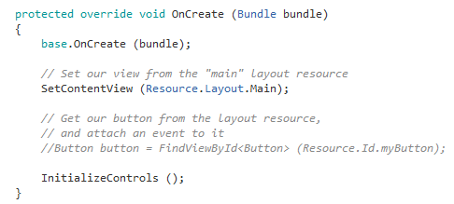

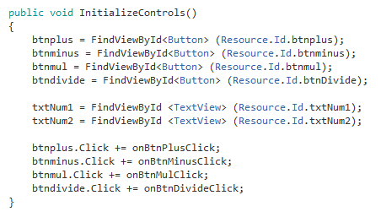

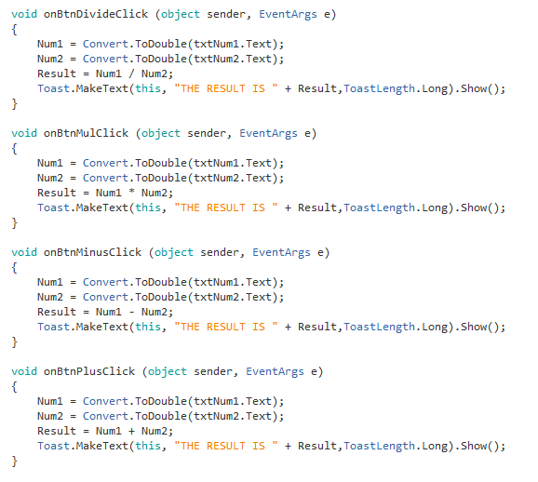

**Styles of Button**

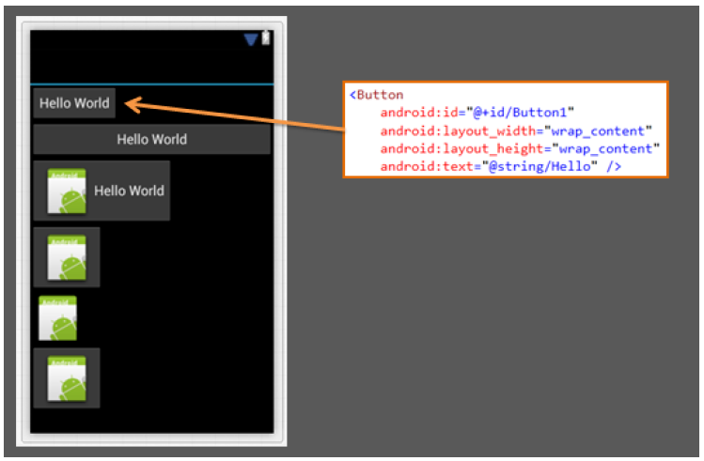

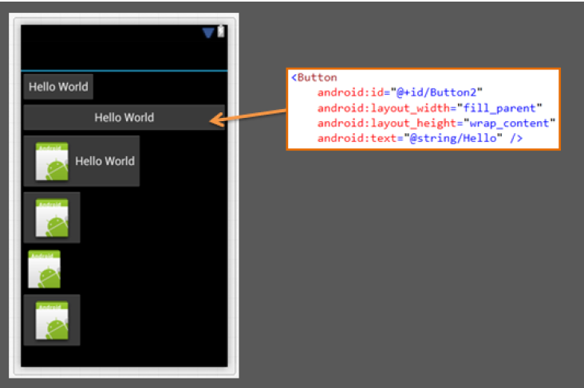

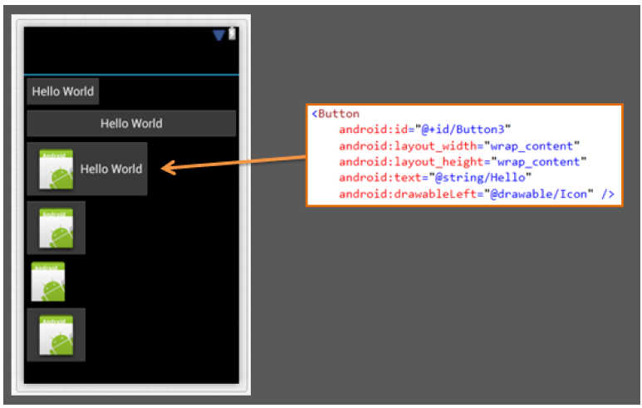

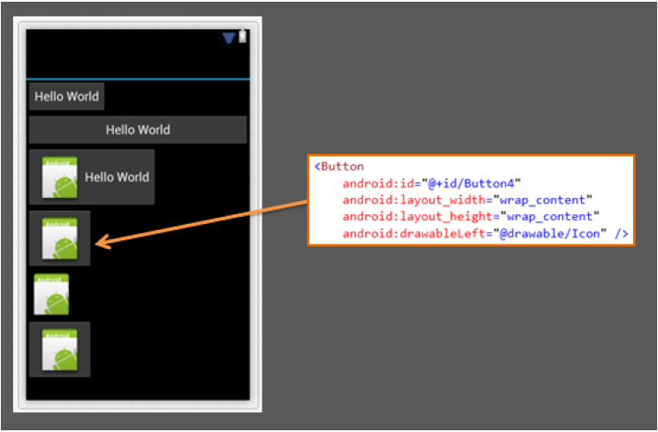

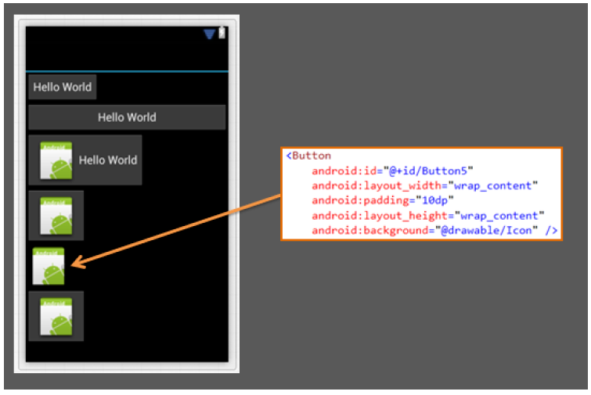

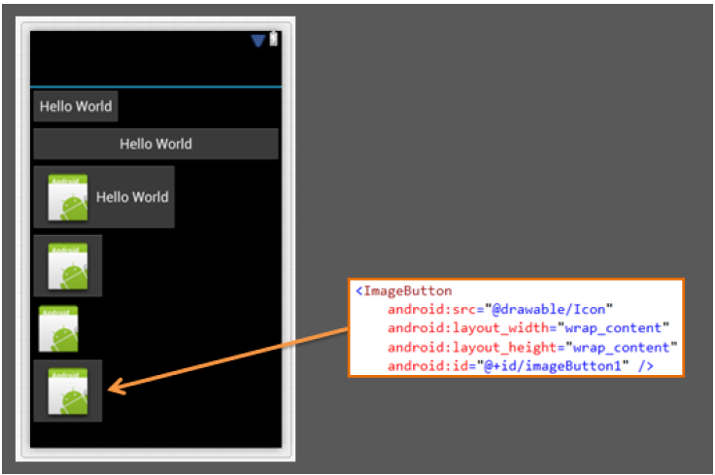

**BMI Calculator**

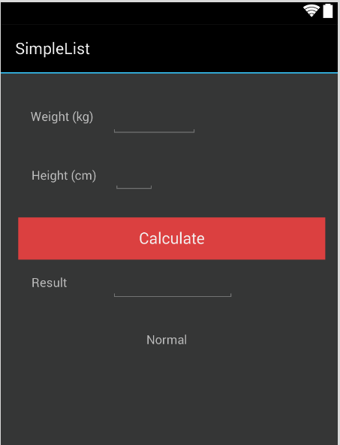

Design an app as shown above using DroidDraw

The formula for BMI goes like this

**BMI = Weight / (Height * Height)**

|  |  |
| --- | --- |
| BMI | Result |
| < 18.5 | Underweight |
| 18.6 to 24.9 | Normal |
| 25 to 29.9 | Overweight |
| > 30 | Obese |

1. Design a Math Tester using Random Numbers

Package your app and send it to your friends